Project Planning Phase
DocBook — Doctor Appointment Booking System (MERN Stack)
Project Name | DocBook — Doctor Appointment Booking System
Team ID | ________________________
Date | 19 July 2026
Domain | Web Application — MERN (MongoDB, Express, React, Node.js)
Maximum Marks | 5 Marks

Planning Logic
- Sprint — a fixed period of time in which the team works to complete a set of tasks. This project is planned across 3 sprints.
- Epic — a large feature area that is too big to finish in one sprint, broken down into smaller Stories. DocBook has 5 Epics: Authentication, Doctor Directory, Appointment Booking, Doctor Dashboard, and Admin Management.
- Story — a small, independently deliverable task that belongs to an Epic (e.g. "Book an appointment slot").
- Story Point — a number representing the effort a story takes, estimated on the Fibonacci scale below.
Story Point scale (1, 2, 3, 5):
Points | Effort
1 | Very easy task
2 | Normal task
3 | Moderate task
5 | Difficult task

Product Backlog & Sprint Schedule
Each story is mapped to the file in the codebase that implements it, so the backlog traces directly to the delivered MERN project.
Sprint | Epic | Story No. | User Story / Task | Points | Priority | Implementation
Sprint-1 | Authentication  (Epic 1) | USN-1 | As a user, I can register as a patient or doctor by entering my name, email, and password. | 3 | High | authController.js / Register.jsx
Sprint-1 |  | USN-2 | As a user, I can log in with my email and password and receive a JWT session token. | 2 | High | authController.js / Login.jsx
Sprint-1 | Doctor Directory  (Epic 2) | USN-3 | As a patient, I can browse the list of active doctors. | 3 | High | doctorController.js / Doctors.jsx
Sprint-1 |  | USN-4 | As a patient, I can filter or search doctors by specialty or name. | 2 | Medium | doctorController.js / Doctors.jsx
Sprint-2 | Appointment  Booking (Epic 3) | USN-5 | As a patient, I can view a doctor's profile and live slot availability for a chosen date. | 3 | High | getAvailability() / DoctorDetail.jsx
Sprint-2 |  | USN-6 | As a patient, I can book an appointment by selecting a date, time slot, and reason. | 3 | High | bookAppointment() / DoctorDetail.jsx
Sprint-2 |  | USN-7 | As a patient, I can view all my upcoming and past appointments. | 2 | High | getMyAppointments() / MyAppointments.jsx
Sprint-2 |  | USN-8 | As a patient, I can cancel an appointment I no longer need. | 2 | Medium | cancelAppointment() / MyAppointments.jsx
Sprint-3 | Doctor Dashboard  (Epic 4) | USN-9 | As a doctor, I can view the appointments patients have booked with me. | 2 | High | getDoctorAppointments() / DoctorDashboard.jsx
Sprint-3 |  | USN-10 | As a doctor, I can confirm, mark complete, or cancel a booking. | 3 | Medium | updateStatus() / DoctorDashboard.jsx
Sprint-3 | Admin  Management (Epic 5) | USN-11 | As an admin, I can add or remove doctors from the public directory. | 3 | High | createDoctor() / AdminDashboard.jsx
Sprint-3 |  | USN-12 | As an admin, I can view every appointment booked across the system. | 2 | Medium | getAllAppointments() / AdminDashboard.jsx
Sprint totals: Sprint-1 = 10 pts · Sprint-2 = 10 pts · Sprint-3 = 10 pts

Sprint Tracker & Velocity
Sprint | Total Points | Duration | Start Date | End Date (Planned) | Points Completed | Release Date (Actual)
Sprint-1 | 10 | 6 Days | 01 Jun 2026 | 06 Jun 2026 | 10 | 06 Jun 2026
Sprint-2 | 10 | 6 Days | 08 Jun 2026 | 13 Jun 2026 | 10 | 13 Jun 2026
Sprint-3 | 10 | 6 Days | 15 Jun 2026 | 20 Jun 2026 | 10 | 20 Jun 2026

Velocity
Velocity = Total Story Points Completed / Number of Sprints
Total Story Points = 10 + 10 + 10 = 30
Number of Sprints = 3
Velocity = 30 / 3 = 10
The team's velocity is 10 Story Points per Sprint.

Application Screenshots
Captured directly from the running DocBook application.
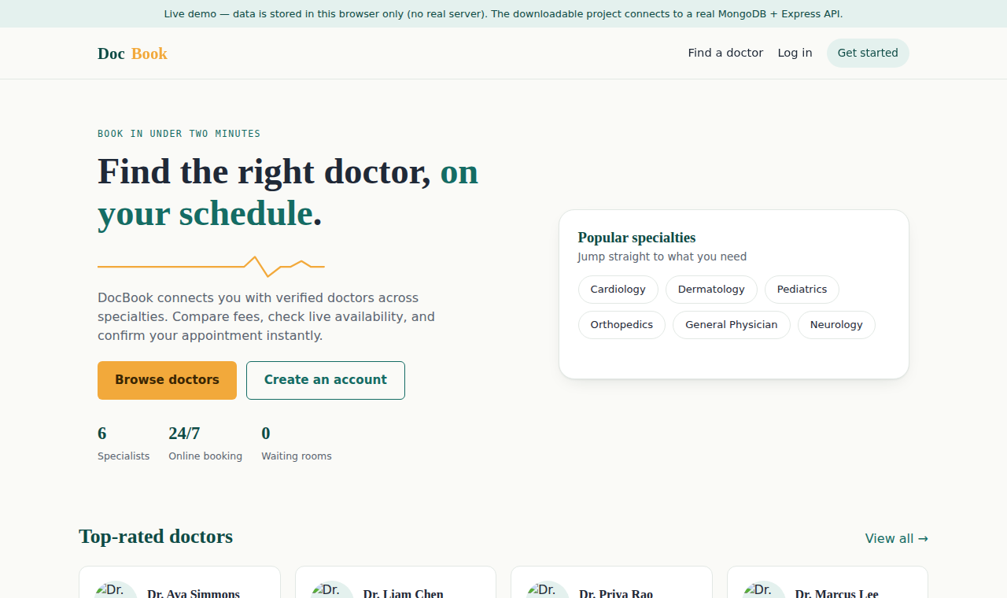  Fig 1: Home Page | 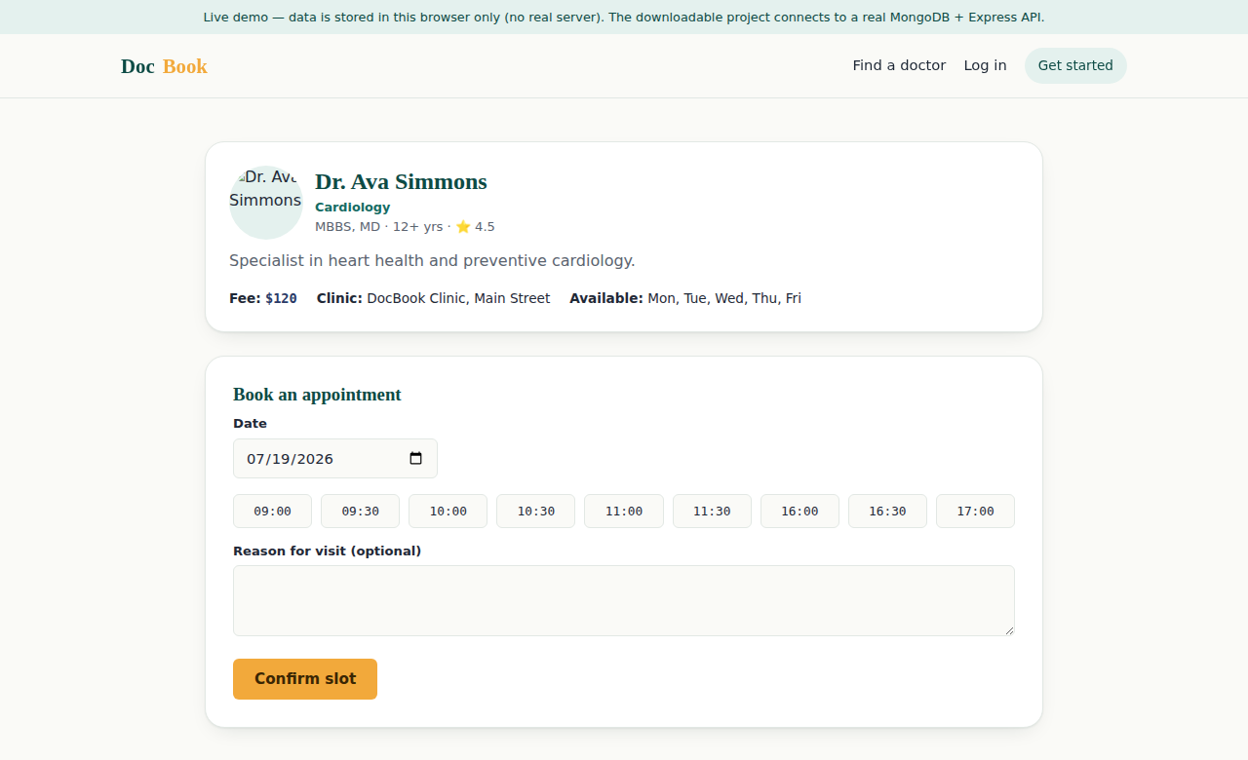  Fig 2: Doctor Booking | 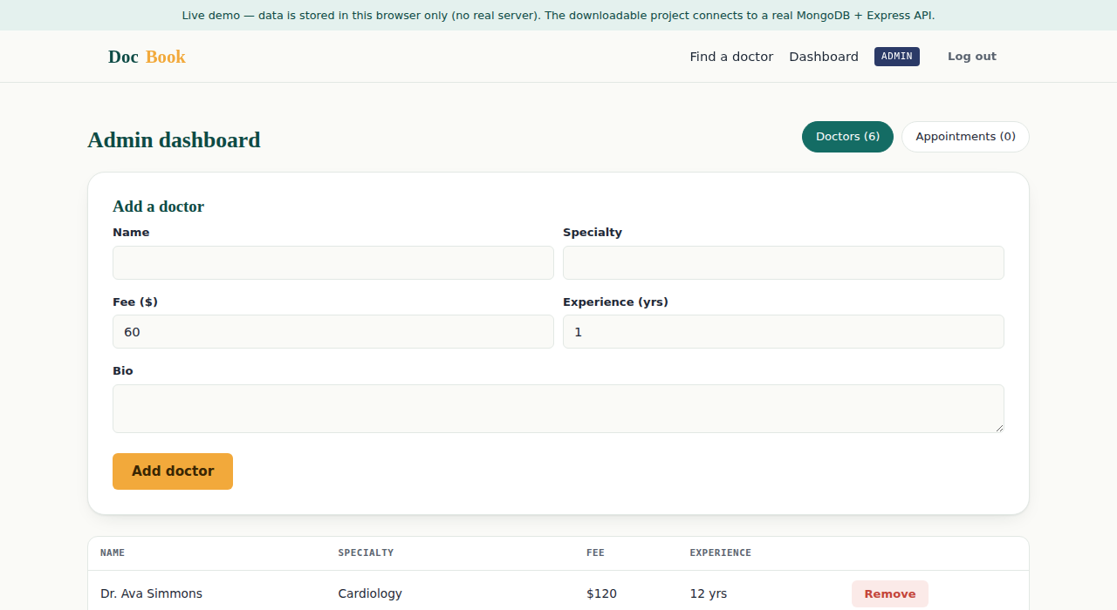  Fig 3: Admin Dashboard

